PANKAJ KUMAR
Python Programming Assignment - 01
Program: PGCP-ITISS
Module: Programming Concepts

Q1 Write a Python program to print the following output:
Print ("Welcome to Python Programming")
Print ("Course: PG-DVLSI")
Print ("Institute: CDAC")
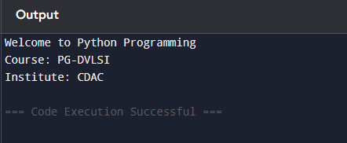
Q2 Write a program to perform addition, subtraction, multiplication, and division of two numbers
entered by the user.
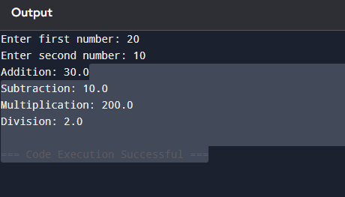
num1 = float(input("Enter first number: "))
num2 = float(input("Enter second number: "))
addition = num1 + num2
subtraction = num1 - num2
multiplication = num1 * num2
if num2 != 0:
division = num1 / num2
else:
division = "Undefined (cannot divide by zero)"
print("Addition:", addition)
print("Subtraction:", subtraction)
print("Multiplication:", multiplication)
print("Division:", division)
Q 3-Write a program to calculate the area and perimeter of a rectangle using user input.
length = float(input("Enter length of rectangle: "))
width = float(input("Enter width of rectangle: "))
area = length * width
perimeter = 2 * (length + width)
print("Area of rectangle:", area)
print("Perimeter of rectangle:", perimeter)


Q4 Write a program to demonstrate print() formatting using sep and end.
print("Python", "VLSI", sep="-", end="-")
print("CDAC")
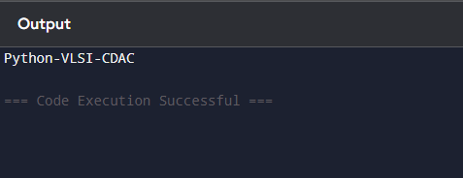

Q5 Write a program to demonstrate bitwise operations (AND, OR, XOR, Left Shift, Right Shift) on
two numbers.
a = int(input("Enter first number: "))
b = int(input("Enter second number: "))
print("AND (a & b):", a & b)
print("OR (a | b):", a | b)
print("XOR (a ^ b):", a ^ b)
print("Left Shift (a << 1):", a << 1)
print("Right Shift (a >> 1):", a >> 1)
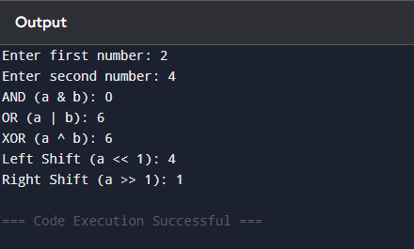

Q6 Write a Python program to check whether a number is:
Positive
Negative
Zero
num = float(input("Enter a number: "))
if num > 0:
print("Positive")
elif num < 0:
print("Negative")
else:
print("Zero")
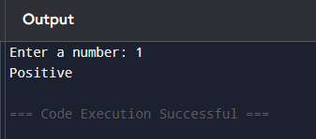
Q7 Write a program to check whether a number is even or odd.

num = int(input("Enter a number: "))
if num % 2 == 0:
print("Even")
else:
print("Odd")
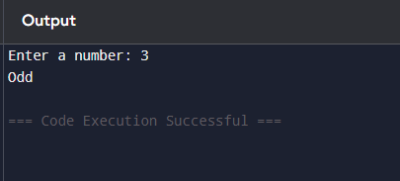
Q8 Write a program to find the largest among three numbers entered by the user.

